RMB Navigation to Finance Project – C0527

|  |  |  |  |  |
| --- | --- | --- | --- | --- |
| **Ver** | **Date** | **Author** | **Comments** | **Reviewed by** |
| 1 | 08/02/2020 | Tom Bell | CRIM 0527 | TBC |
|  |  |  |  |  |

Requirements 2

Prerequisites 2

Solution Overview 2

Solution Details 2

Security 3

Companies 3

Data Migration 3

Test Steps 3

Technical Implementation 3

Requirements

An RMB option from the (Project Management>Plan and Execute> ) Project screen header must be available that navigates to the (Financials>Project Accounting>) Finance Project screen, displaying the Project of who’s header was RMB’d.

Prerequisites

<Describe any pre-requisites that this development may rely upon, data configuration or other developments>

Solution Overview

An RMB option from the (Project Management>Plan and Execute> ) Project screen header must be available that navigates to the (Financials>Project Accounting>) Finance Project screen, displaying the Project of who’s header was RMB’d.

RMB Name

* “Financial Project”

Solution Details

The below screenshot shows where the RMB option “Financial Project” must be available from in red.

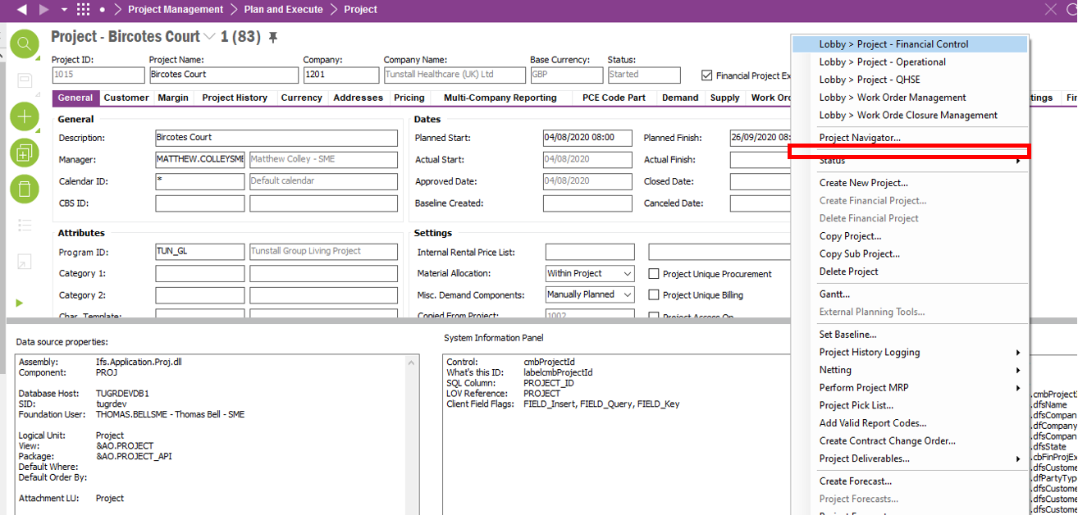

The below screenshot shows the Financials>Project Accounting> Finance Project screen. This is the screen that must be navigated to when the RMB is selected. Depending on the Project header that is RMB’d will determine which Finance project is opened (see in red the Project ID).

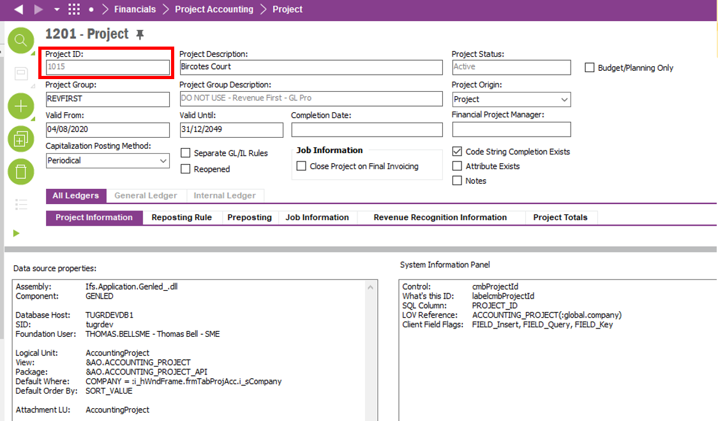

**Technical.**

Field Definitions.

<New Field/CLU Definition>

|  |  |  |  |  |  |  |
| --- | --- | --- | --- | --- | --- | --- |
| New DB Object Name | DB Object Item/Field Names | Item Description | Item Data Type | Item Syntax | Calculation Spec, if Derived | LOVs/Enums/Is Mandatory? |
|  |  |  |  |  |  |  |
|  |  |  |  |  |  |  |
|  |  |  |  |  |  |  |
|  |  |  |  |  |  |  |
|  |  |  |  |  |  |  |
|  |  |  |  |  |  |  |
|  |  |  |  |  |  |  |
|  |  |  |  |  |  |  |
|  |  |  |  |  |  |  |
|  |  |  |  |  |  |  |
|  |  |  |  |  |  |  |
|  |  |  |  |  |  |  |

Security

<Define security controls> (Who needs access to this and will it be restricted from any other users etc)

Companies

Applies to the following companies. All.

|  |  |
| --- | --- |
| **Company** | **Required (Y/N)** |
| 1201 | Y |
| TBC |  |
|  |  |

Data Migration

<Describe any data migration impacts this development may have – i.e additional data to be migrated>

Test Steps

<Steps that needs to be taken to test this change. Please provide expected results> Updated post solution.

|  |  |  |
| --- | --- | --- |
| **No** | **Script\Test Steps** | **Expected Result** |
| 1 | In Project Management>Plan and Execute> Project screen when RMB-ing in the header | Must see the RMB option “Financial Project” under the RMB “Project Navigator”. |
| 2 | Clicking the Financial Project RMB | Must take the n the Financials>Project Accounting> Finance Project screen of the Project of who’s header was RMB’d. |

Technical Implementation

<Completed by the technical developer - Technical solution, list packages, functions, Custom menus created etc >

**Package**

EA_FINANCE

**Permission Granted**

IFS_ALL

**Custom Menus (RMBs)**

